Experiment 4
A
Code:
import javax.crypto.Cipher;
import javax.crypto.spec.SecretKeySpec;
import java.util.*;

class Main {
public static void main(String[] args) throws Exception {

Scanner sc = new Scanner(System.in);

String key = "12345678";

System.out.print("Enter Plaintext: ");
String text = sc.nextLine();

SecretKeySpec k = new SecretKeySpec(key.getBytes(), "DES");
Cipher c = Cipher.getInstance("DES");

// Encrypt
c.init(Cipher.ENCRYPT_MODE, k);
byte[] encrypted = c.doFinal(text.getBytes());

System.out.println("Encrypted Data: " +
Base64.getEncoder().encodeToString(encrypted));

// Decrypt
c.init(Cipher.DECRYPT_MODE, k);
byte[] decrypted = c.doFinal(encrypted);

System.out.println("Decrypted Data: " +
new String(decrypted));
}
}
Output:
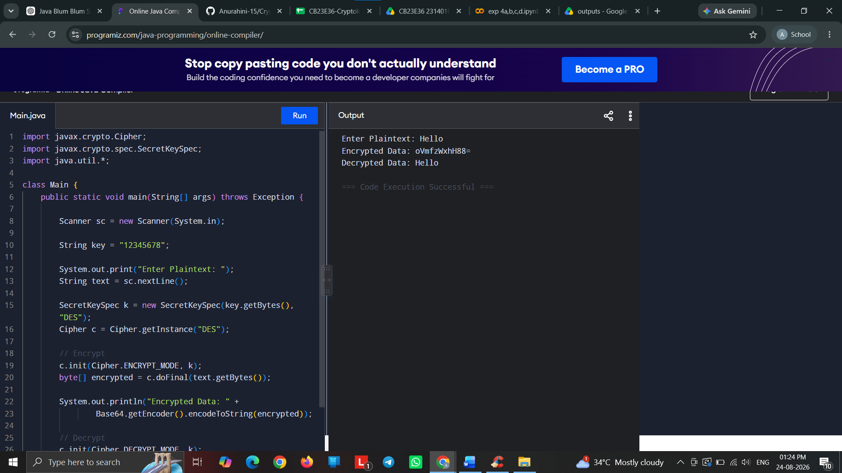

B
Code
import java.util.*;

class Main {
public static void main(String[] args) {

Scanner sc = new Scanner(System.in);

int p = 17;
int q = 11;
int n = p * q;
int phi = (p - 1) * (q - 1);
int e = 7;

int d = 1;

for (int i = 1; i < phi; i++) {
if ((e * i) % phi == 1) {
d = i;
break;
}
}

System.out.println("Public Key: (" + e + "," + n + ")");
System.out.println("Private Key: (" + d + "," + n + ")");

System.out.print("Enter Message (<187): ");
int message = sc.nextInt();

int cipher = 1;

for (int i = 0; i < e; i++)
cipher = (cipher * message) % n;

System.out.println("Encrypted Message: " + cipher);

int plain = 1;

for (int i = 0; i < d; i++)
plain = (plain * cipher) % n;

System.out.println("Decrypted Message: " + plain);
}
}
Output:
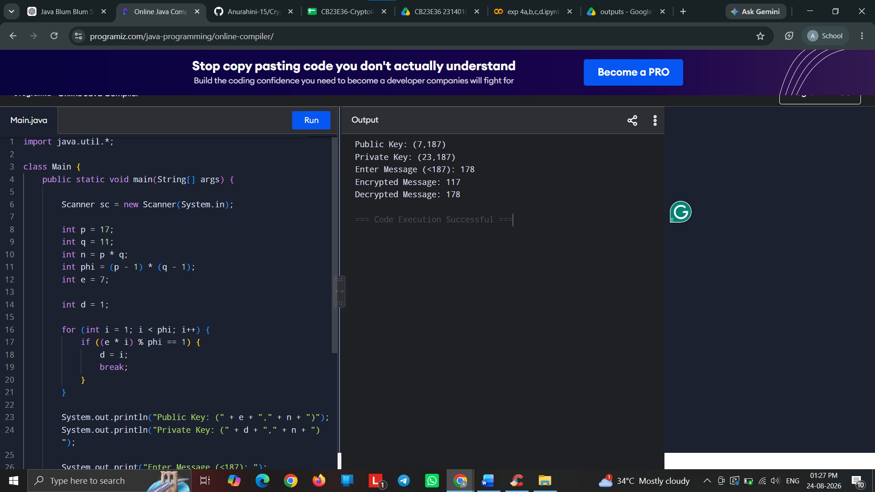

C
Code:
import java.util.*;
import java.security.*;

class Main {
public static void main(String[] args) throws Exception {

Scanner sc = new Scanner(System.in);

System.out.print("Enter Message: ");
String message = sc.nextLine();

MessageDigest md = MessageDigest.getInstance("MD5");

byte[] hash = md.digest(message.getBytes());

String result = "";

for (byte b : hash)
result += String.format("%02x", b);

System.out.println("MD5 Digest: " + result);
}
}
Output:
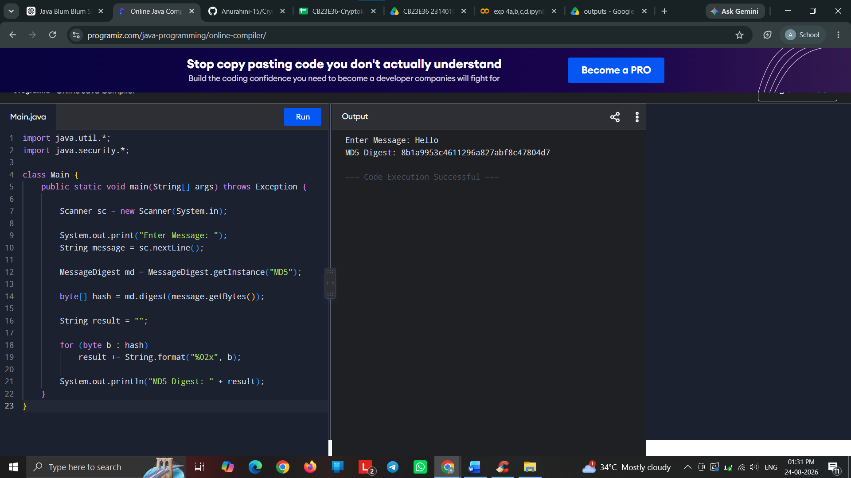

D
Code:
import java.util.*;
import java.security.*;

class Main {
public static void main(String[] args) throws Exception {

Scanner sc = new Scanner(System.in);

System.out.print("Enter Message: ");
String message = sc.nextLine();

MessageDigest md = MessageDigest.getInstance("SHA-1");

byte[] hash = md.digest(message.getBytes());

String result = "";

for (byte b : hash)
result += String.format("%02x", b);

System.out.println("SHA-1 Digest: " + result);
}
}
Output:
